

**[ FUNDAMENTALS OF PROGRAMMING -LAB ]**

**LAB TASK MANUAL-8**

**TALHA MATEEN**

**454713**

**SEC A**

**ME-15**

**QUESTION NO.1**

//Write a C++ program to calculate average of numbers of array

#include <iostream>

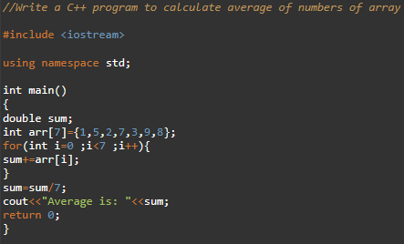

using namespace std;

int main()

{

double sum;

int arr[7]={1,5,2,7,3,9,8};

for(int i=0 ;i<7 ;i++){

sum+=arr[i];

}

sum=sum/7;

cout<<"Average is: "<<sum;

return 0;

}



**QUESTION NO.2**

//Implement Bubble sort on an array of 5 integers.

#include <iostream>

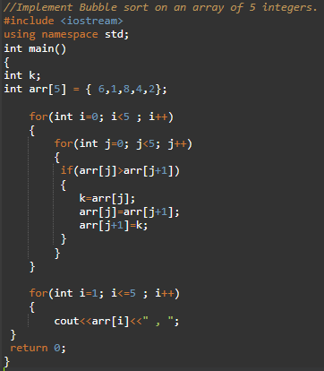using namespace std;

int main()

{

int k;

int arr[5] = { 6,1,8,4,2};

for(int i=0; i<5 ; i++)

{

for(int j=0; j<5; j++)

{

if(arr[j]>arr[j+1])

{

k=arr[j];

arr[j]=arr[j+1];

arr[j+1]=k;

}­­­­­

}

}

for(int i=1; i<=5 ; i++)

{

cout<<arr[i]<<" , ";

}

return 0;

}



**QUESTION NO.3**

//Implement Selection Sort on an array of 5 integers

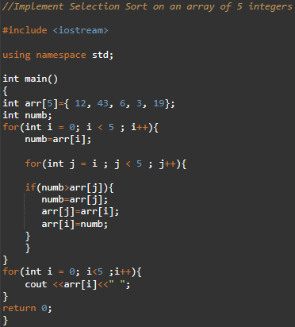#include <iostream>

using namespace std;

int main()

{

int arr[5]={ 12, 43, 6, 3, 19};

int numb;

for(int i = 0; i < 5 ; i++){

numb=arr[i];

for(int j = i ; j < 5 ; j++){

if(numb>arr[j]){

numb=arr[j];

arr[j]=arr[i];

arr[i]=numb;

}

}

}

for(int i = 0; i<5 ;i++){

cout <<arr[i]<<" ";

}

return 0;}

